APPLICATION DEVELOPMENT

UI DESIGN
Smart Farming and Precision Agriculture Management System

NAME : RUTHRAGURUBARAN J
REGISTER NO : 727824TUIT157
DEGREE & : B.TECH IT BRANCH
CLASS &SEC : 3rd IT –“F”

1.Login Page
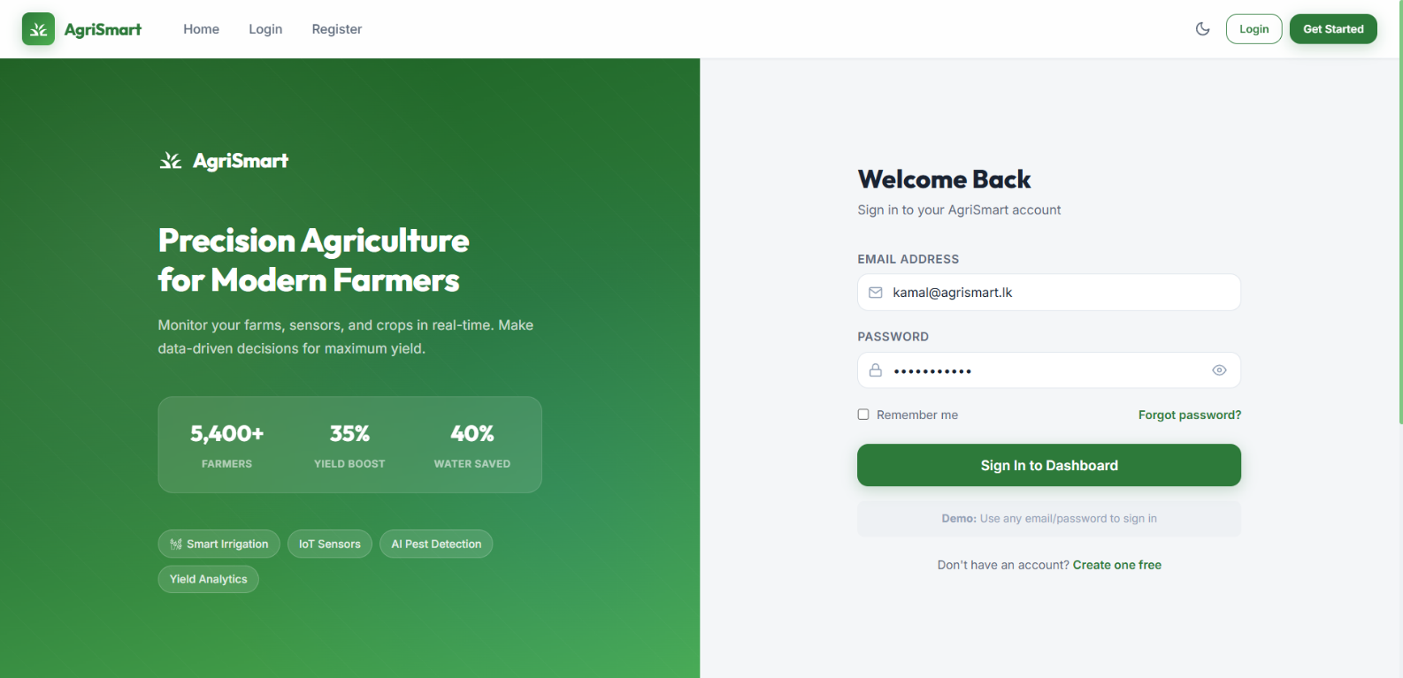

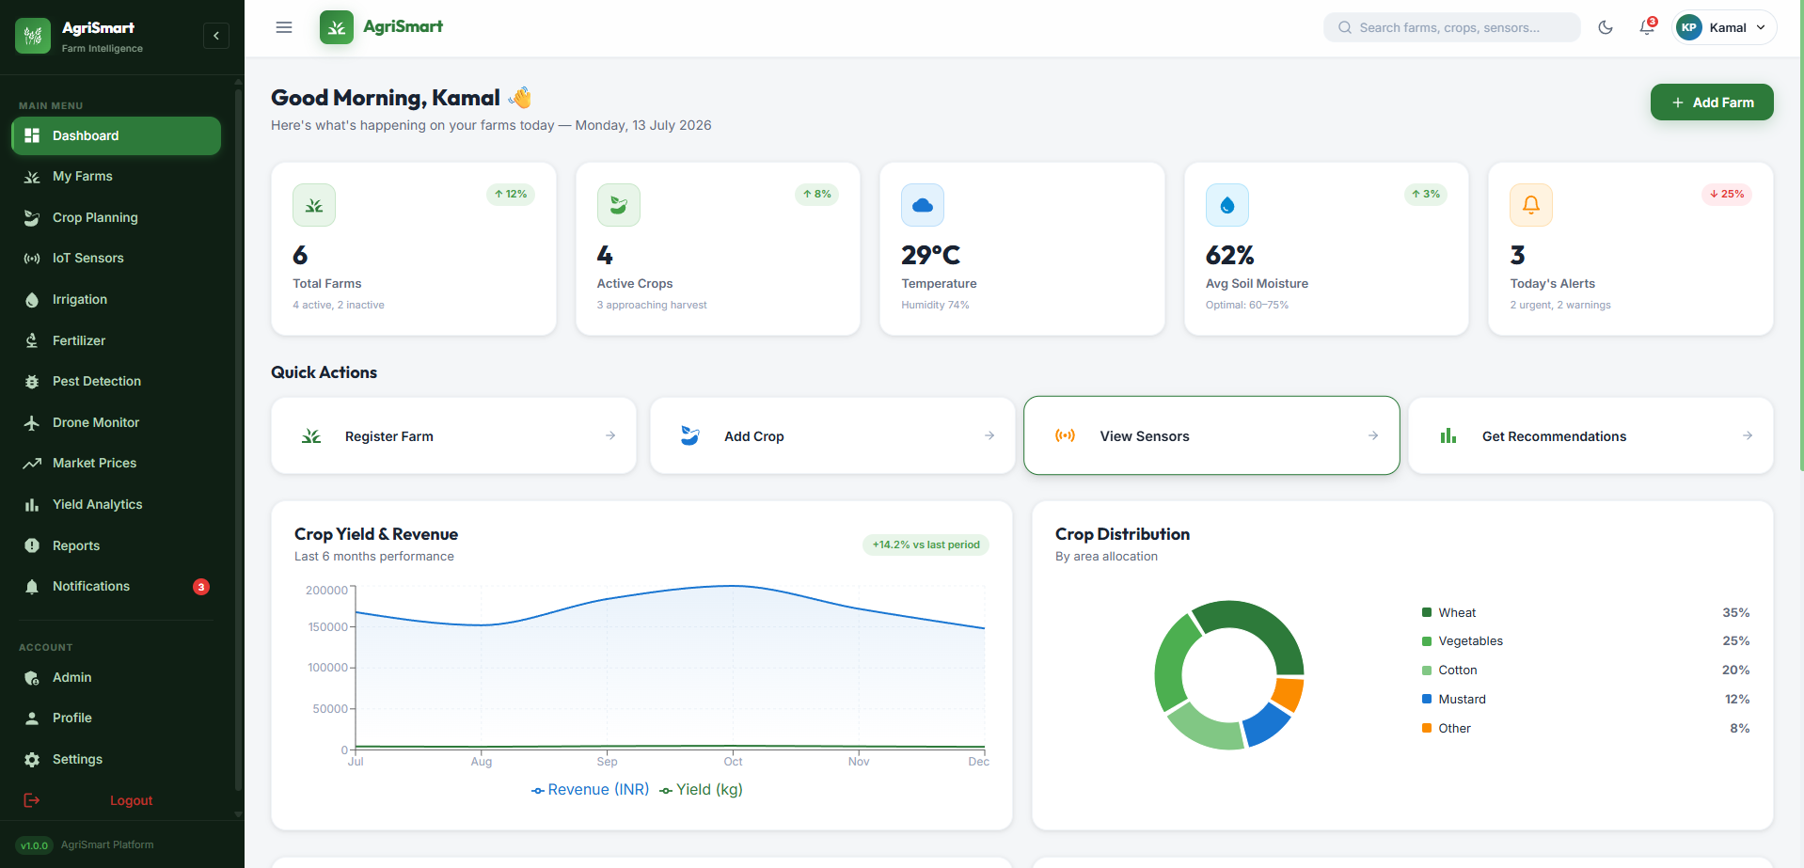
2.Dashboard (Home)

3.Farm Management
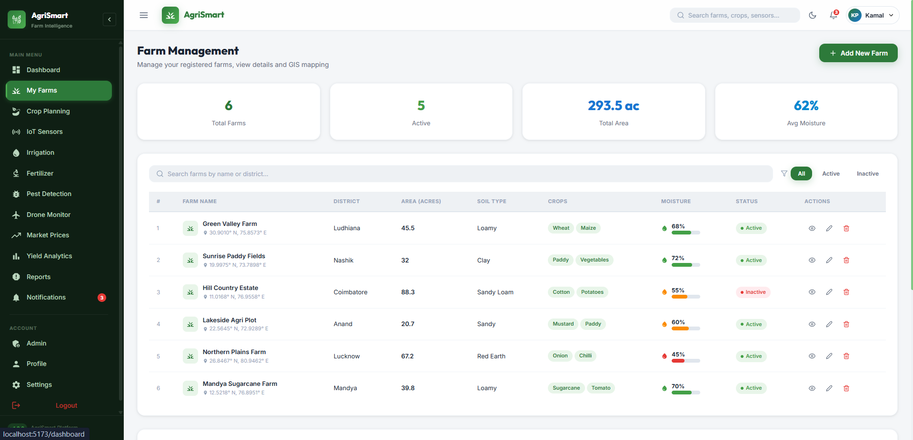

4.IoT Sensors Dashboard
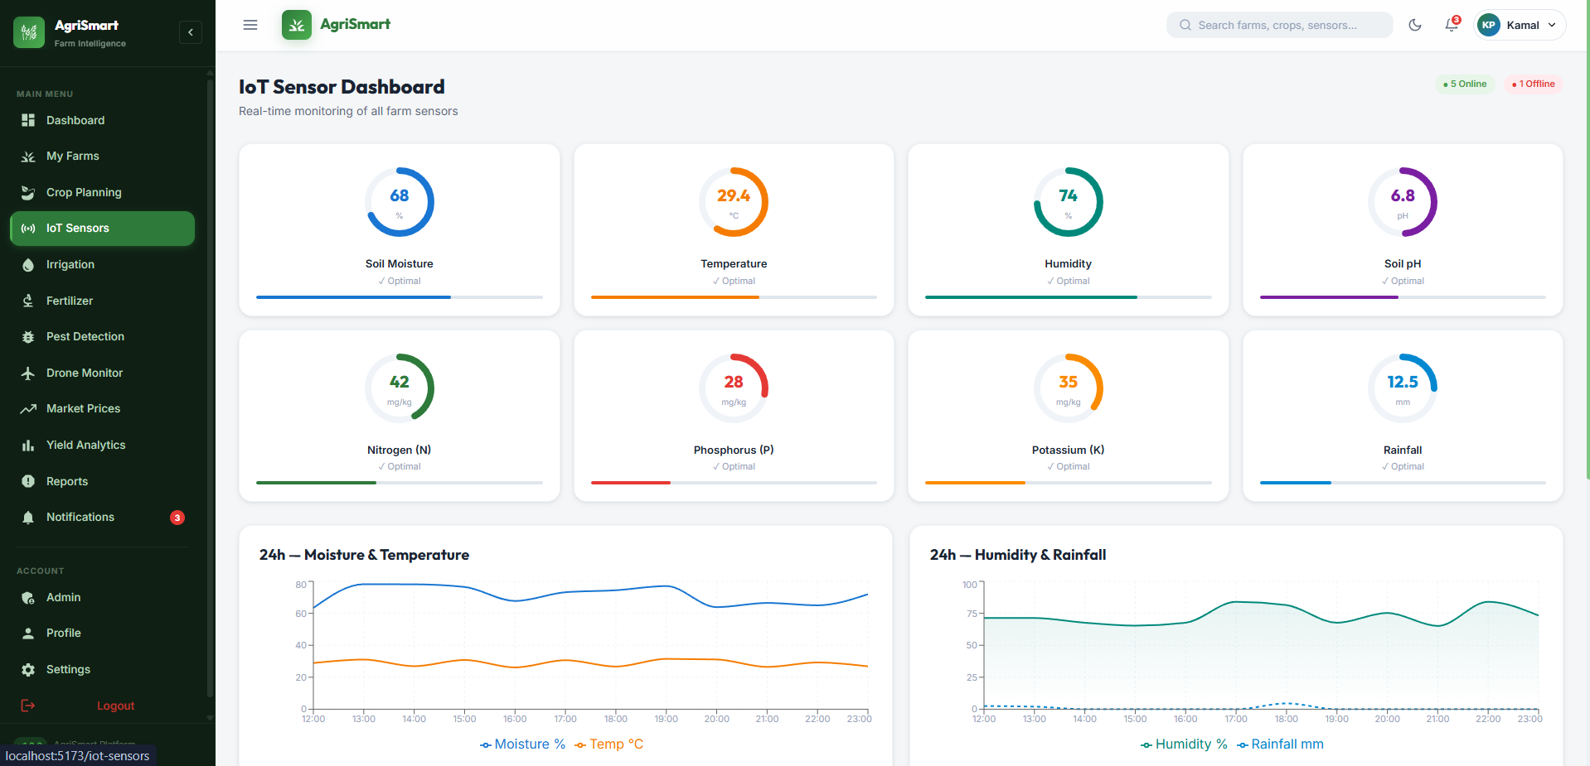

5.Drone Monitor
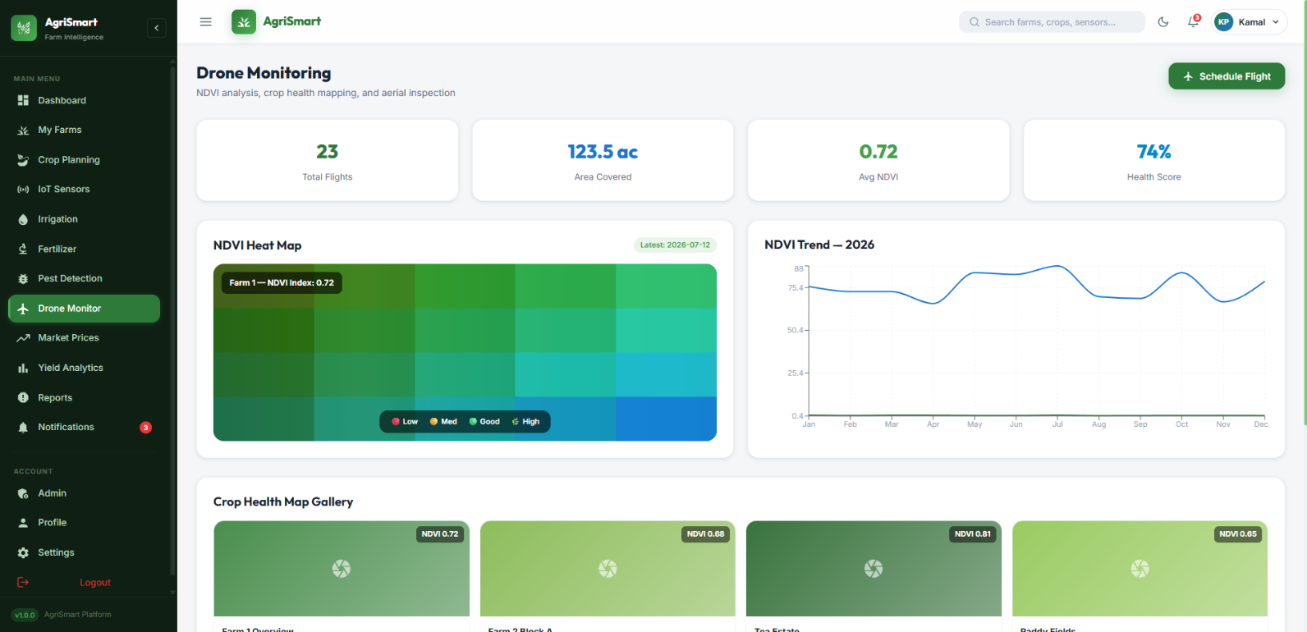

6.Profile page
